A PROJECT TITLE

ON

Vehicle CO₂ Emission Prediction Using Elastic Net Regression

project report submitted in partial fulfilment of the requirements for the Course

MACHINE LEARNING

BACHELOR OF TECHNOLOGY

In

A.Y.: 2026-27

By

S. Bheeshma Roll No. 2520030528

Under the Esteemed guidance of

Dr. Rani

Associate Professor, CSE

Department of Computer Science and Engineering





Abstract
This project presents the design, implementation, and evaluation of a machine learning system for predicting vehicle carbon dioxide (CO₂) emissions. Using a dataset of 7,385 vehicle records that describe engine size, number of cylinders, fuel type, transmission, vehicle class and fuel consumption, an Elastic Net Regression model, which combines Ridge (L2) and Lasso (L1) penalties, is built to estimate CO₂ emissions in grams per kilometre. The study covers data loading and inspection, removal of identifier columns (make and model), one-hot encoding of categorical variables, standardisation of numerical features, exploratory data analysis, model training on 80% of the data and testing on the remaining 20%. On the held-out test set of 1,477 records, the model achieved a Mean Absolute Error of 4.76 g/km, a Root Mean Squared Error of 7.08 g/km and an R² score of 0.9854, showing that vehicle specifications and fuel-consumption figures alone explain almost all of the variation in emissions. The results are compared with published studies, and the limitations and practical implications of the approach are discussed.
Keywords: Elastic Net regression; CO₂ emission prediction; vehicle emissions; regularization; exploratory data analysis; machine learning

1. Introduction

1.1 Purpose of the Project
Road transport is one of the largest sources of greenhouse-gas emissions, and carbon dioxide (CO₂) is the main gas released when petrol, diesel and other fuels are burned in vehicle engines [1], [10]. Regulators, manufacturers and buyers all need reliable estimates of how much CO₂ a vehicle emits per kilometre: regulators to set and enforce emission standards, manufacturers to design cleaner engines, and consumers to choose efficient vehicles and judge their environmental impact.
A vehicle’s emissions depend on several interacting factors, including engine size, number of cylinders, fuel type, transmission and fuel consumption. Estimating them by hand, or testing every vehicle physically, is slow and does not scale to thousands of models. A machine learning model can learn these relationships directly from existing vehicle records and then give fast, consistent predictions for any vehicle described by the same attributes, which is the motivation for this project.

1.2 Problem Statement
The problem addressed here is a supervised regression task. Given the technical specification of a vehicle (engine size, number of cylinders, fuel type, transmission type, vehicle class, and city, highway and combined fuel consumption), the model must predict the vehicle’s CO₂ emissions in grams per kilometre (g/km). The output is a single continuous value for each vehicle, and prediction quality is judged by how closely the predicted values match the recorded emissions of vehicles that were not used for training.

1.3 Existing Methods and Disadvantages
Existing approaches to vehicle CO₂ estimation fall into two groups. Laboratory and on-road measurement gives accurate figures, but it needs specialised equipment, takes time and cannot be applied to every vehicle variant. Data-driven studies instead apply regression and learning algorithms to vehicle datasets; recent work compares linear regression, k-nearest neighbours, random forests, gradient-boosting ensembles such as XGBoost and CatBoost, and deep networks such as CNN, LSTM and GRU [1], [3], [4], [5]. Ensemble and deep models often reach very high accuracy, but deep models take longer to train and need more computing resources [1], and many high-performing models behave as black boxes that give little insight into how inputs drive the predictions [5].
Plain linear models are fast and easy to interpret, and one study found that they can match non-linear models on this kind of data [2]. Their weakness is that fuel-consumption measures and engine attributes are strongly correlated with each other. Without regularisation, this multicollinearity makes coefficient estimates unstable and encourages overfitting; one study reports a condition number of about 1.84 × 10¹⁷ for an unregularised model before feature selection [1]. Ridge regression shrinks correlated coefficients but never removes a feature, whereas Lasso selects features but tends to keep only one variable from a group of highly correlated predictors [11]. These limitations motivate a method that combines both penalties.

1.4 Proposed System
The proposed system trains an Elastic Net Regression model [11] on a cleaned and encoded vehicle dataset. The pipeline loads the dataset, inspects its structure, statistics, missing values and duplicates, drops the identifier columns Make and Model, one-hot encodes Fuel Type, Vehicle Class and Transmission, and standardises the numerical features so that every feature contributes on the same scale. After exploratory analysis, the data are split 80:20 into training and test sets, the Elastic Net model is fitted on the training set, and its predictions are evaluated using MAE, RMSE and R². By mixing L1 and L2 penalties, Elastic Net can shrink the influence of weak features while keeping groups of correlated features together, which gives stable and generalisable predictions. The expected contribution is a lightweight, reproducible model that estimates a vehicle’s CO₂ emissions from its specification without physical testing.

1.5 Research Objectives( atleast 4)
- Collect a real-world vehicle dataset that contains technical specifications and CO₂ emission values.
- Clean the data by checking missing values and duplicates and removing irrelevant columns, then encode and scale the features for modelling.
- Analyse the distribution of CO₂ emissions and its relationship with engine size, fuel type, transmission and fuel consumption through exploratory data analysis.
- Build an Elastic Net Regression model that balances Ridge and Lasso regularisation for stable, generalisable predictions.
- Evaluate the model with MAE, RMSE and R² to measure how closely predictions match actual emissions.
- Compare the result with published studies and discuss how the model can be used to predict the CO₂ emissions (g/km) of any vehicle.

2. Literature Survey (recent studies from 2-3 years)
Ten recent studies (2023–2025) on predicting vehicle CO₂ emissions with machine learning are reviewed below. Their problem statements, objectives, methods, inferences and recommendations are summarised from the published papers and abstracts.
S.No. | Title | Reference with DOI | Problem or gap addressed | Objective of the Research | Focus of the paper (Methods used) | Inference | Recommendations for future research
1 | Forecasting CO₂ emissions of fuel vehicles for an ecological world using ensemble learning, machine learning, and deep learning models | F. Gurcan, PeerJ Computer Science, 2024, art. e2234. doi: 10.7717/peerj-cs.2234 | Room remains to improve the prediction performance and interpretability of vehicle CO₂ models. | Compare 18 regression algorithms for predicting CO₂ of fuel vehicles. | Machine learning, ensemble and deep learning regressors; one-hot encoding, min-max scaling, feature selection; 80/20 split; R², adjusted R², RMSE, runtime. | Ensemble methods (XGBoost, Random Forest, LightGBM) were most effective; XGBoost reached R² 0.9979, RMSE 2.66. Deep models needed more training time. | Validate on larger datasets and with other modelling approaches; account for the effect of scaling and preprocessing choices.
2 | Effective modeling of CO₂ emissions for light-duty vehicles: linear and non-linear models with feature selection | H. T. T. Vu and J. Ko, Energies, vol. 17, no. 7, art. 1655, 2024. doi: 10.3390/en17071655 | Light-duty vehicle emission datasets are rich in features and not fully analysed, which makes prediction difficult. | Analyse LDV CO₂ data and identify key characteristics of prediction models. | Linear and non-linear (generalised additive) models with feature selection; correlation analysis. | Linear models performed comparably to non-linear ones with better interpretability and reliability; fuel consumption and powertrain attributes strongly influence emissions. | Choose models and parameters carefully, since non-linear models vary with their settings.
3 | Estimation of CO₂ emissions from vehicles using machine learning and multi-model investigation | M. S. Mungan and O. Arpa, Bull. Pol. Acad. Sci. Tech. Sci., vol. 73, no. 4, art. e154287, 2025. doi: 10.24425/bpasts.2025.154287 | Dataset is geographically limited and lacks dynamic variables such as driving conditions. | Predict vehicle CO₂ emissions with several regression models. | Linear, Lasso, k-NN, Random Forest and CatBoost regression; grid-search tuning; MSE, RMSE, MAE, R². | CatBoost gave the highest accuracy; linear models could not capture complex relationships; engine size, cylinders and fuel consumption correlated 0.92–0.99 with CO₂. | Use explainable AI methods and larger datasets.
4 | Machine learning and deep learning analysis of vehicle carbon footprint | R. Dhyan, H. K. Joy, R. Sridevi, J. A. Electa Alice and D. Vanusha, Int. J. Environ. Impacts, vol. 7, no. 2, 2024. doi: 10.18280/ijei.070213 | Fuel use in vehicles raises CO₂ emissions; the interaction between vehicle attributes and emissions is complex. | Analyse a fuel-consumption dataset (urban, highway, combined) and predict CO₂ emissions. | Linear regression, Random Forest, SVM, CNN and RNN. | Random Forest and the deep learning models gave the best results. | Large-scale data cleansing and further study to improve model accuracy and performance.
5 | Green driving: harnessing machine learning to predict vehicle carbon footprints and interpreting results with explainable AI | A. B. S. Mahi, F. S. Eshita, M. T. Maisha, A. K. Saha and S. M. R. Al Masud, in Machine Learning Technologies on Energy Economics and Finance, Springer, 2025, pp. 1–26. doi: 10.1007/978-3-031-95099-5_1 | Emission models suffer from insufficient or outdated data and often act as black boxes. | Evaluate eight ML models for vehicle CO₂ and explain their predictions. | Linear Regression, Random Forest, k-NN, SVR, Elastic Net, XGBoost, LightGBM, Bayesian Ridge; Shapash and ELI5 explainability. | Random Forest performed best (R² 99.78%); explainability tools revealed which inputs drive emissions. | Pair high-accuracy models with explainability techniques.
6 | Regression analysis using machine learning algorithms to predict CO₂ emissions | L. A. Joshy, R. K. Sambandam, D. Vetriveeran and J. Jenefa, Proc. INDIACom 2024, pp. 444–448. doi: 10.23919/INDIACom61295.2024.10499094 | Accurate measurement of fuel consumption and emissions is needed for transport emission control. | Build models that estimate CO₂ emissions from vehicle attributes. | Preprocessing, EDA and tuned regression models (including k-NN and Random Forest) on the Canadian vehicle CO₂ dataset; R² and MAPE. | Tuned models were compared by R² and MAPE to rank their predictive accuracy. | Not stated in the indexed abstract.
7 | Forecasting carbon dioxide emissions of light-duty vehicles with different machine learning algorithms | Y. Natarajan, G. Wadhwa, K. R. Sri Preethaa and A. Paul, Electronics, vol. 12, no. 10, art. 2288, 2023. doi: 10.3390/electronics12102288 | Need for reliable CO₂ forecasting for light-duty vehicles. | Predict LDV CO₂ emissions using several ML regression algorithms. | Experimental regression analysis with various machine learning algorithms (as summarised in [1]). | CatBoost predicted CO₂ emissions with reasonable accuracy (as summarised in [1]). | Not stated in the available summary.
8 | Predicting CO₂ emissions from traffic vehicles for sustainable and smart environment using a deep learning model | A. H. Al-Nefaie and T. H. H. Aldhyani, Sustainability, vol. 15, no. 9, art. 7615, 2023. doi: 10.3390/su15097615 | Traffic emissions must be predicted for sustainable and smart environments. | Predict CO₂ emissions of traffic vehicles with a deep learning model. | Bidirectional LSTM (BiLSTM) deep learning model. | BiLSTM achieved an R² of 93.78 (as reported in [1]). | Not stated in the available summary.
9 | Machine-learning-based carbon dioxide concentration prediction for hybrid vehicles | D. Tena-Gago, G. Golcarenarenji, I. Martinez-Alpiste, Q. Wang and J. M. Alcaraz-Calero, Sensors, vol. 23, no. 3, art. 1350, 2023. doi: 10.3390/s23031350 | Need to predict the CO₂ output of hybrid vehicles. | Predict CO₂ for hybrid vehicles using ML models. | New LSTM-based model (UWS-LSTM) compared with traditional and advanced ML models (as summarised in [1]). | An LSTM-based model was proposed for hybrid-vehicle CO₂ prediction (as summarised in [1]). | Not stated in the available summary.
10 | Predicting CO₂ emissions using machine learning methods: a comparative regression and feature importance analysis | T. Parlar, Balkan and Near Eastern Journal of Social Sciences, no. 11, pp. 168–171, 2025. (DOI not listed on the indexed record) | Road transport is a major source of CO₂, and car numbers keep rising. | Build an ML framework to predict vehicle CO₂ emissions and interpret it. | Three regression models compared; SHAP feature-importance analysis. | Ensemble models outperformed linear regression on all evaluation metrics. | Use the insights to support policymakers, manufacturers and consumers in low-carbon transport.

3. Methodology

3.1 Proposed System Flow Diagram
The proposed system follows the pipeline in Fig. 1: the vehicle dataset is inspected and cleaned, identifier columns are dropped, categorical variables are one-hot encoded and numerical features are standardised, the data are explored visually, split into training and test sets, used to train the Elastic Net model, and finally evaluated on the unseen test set.
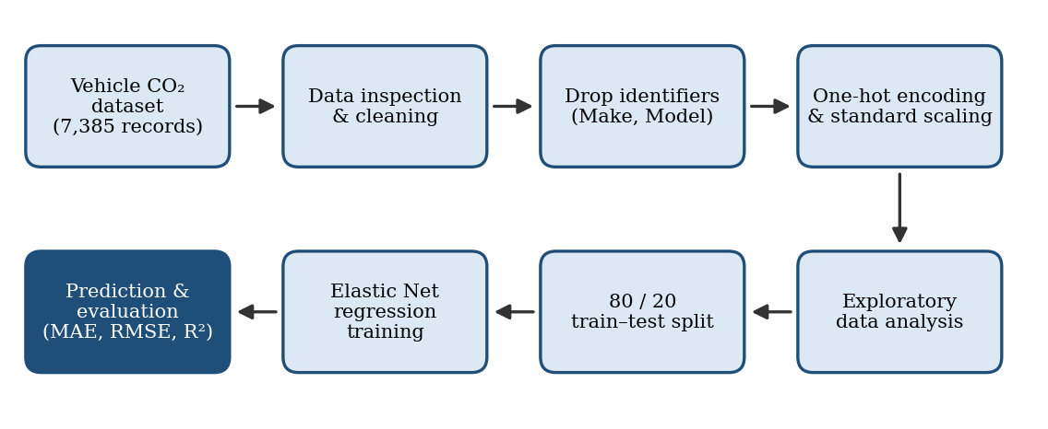
Fig. 1. Proposed system flow diagram.

3.2 Dataset Description
The project uses the Vehicle CO₂ Emission dataset, compiled from real vehicle specification and emissions records; its structure is consistent with the Fuel Consumption Ratings data published by the Government of Canada [13]. It contains 7,385 vehicle records, each described by the attributes in Table 1: vehicle class, engine size, number of cylinders, transmission, fuel type, fuel consumption in city, highway and combined driving, and the make and model identifiers. The target variable is CO₂ emissions in g/km, a continuous quantity, which makes this a regression problem rather than a classification problem. Most vehicles use regular (X, 3,539 records) or premium (Z, 3,022) gasoline, while ethanol (E, 644) and diesel (D, 180) vehicles form smaller groups.
Table 1. Attributes of the vehicle dataset (names as in the supplied file).
Attribute | Type | Summary
MODELYEAR | Integer | 2014 for every record
MAKE | Categorical | 39 manufacturers (identifier; dropped)
MODEL | Categorical | 663 model names (identifier; dropped)
VEHICLECLASS | Categorical | 16 classes; largest are mid-size (1,236), compact (1,178) and small SUV (1,062)
ENGINESIZE | Float (L) | 1.0 – 8.4 (mean 3.35)
CYLINDERS | Integer | 3 – 12 (mean 5.80)
TRANSMISSION | Categorical | 22 codes, e.g. A6, AS6, M6, AV
FUELTYPE | Categorical | X regular gasoline, Z premium gasoline, E ethanol, D diesel
FUELCONSUMPTION_CITY | Float (L/100 km) | 4.6 – 30.2 (mean 13.32)
FUELCONSUMPTION_HWY | Float (L/100 km) | 4.9 – 20.5 (mean 9.49)
FUELCONSUMPTION_COMB | Float (L/100 km) | 4.7 – 25.8 (mean 11.60)
FUELCONSUMPTION_COMB_MPG | Integer (mpg) | 11 – 60 (mean 26.4)
CO₂ emissions (target) | Float (g/km) | Continuous value to be predicted

3.3 Experimental Setup
The experiments were carried out in a Jupyter-style notebook on Google Colab, a cloud-hosted Python 3 environment in which the dataset file is uploaded at the start of the session. No local hardware is required, and the library versions are those provided by the Colab runtime. The Python libraries used are listed in Table 2.
Table 2. Python libraries used and their purpose.
Library | Purpose
Pandas | Load and manipulate the dataset
NumPy | Numerical calculations
Matplotlib | Create graphs and visualisations
Seaborn | Create statistical visualisations
Scikit-learn | Elastic Net model, StandardScaler and evaluation metrics

3.4 Data Preprocessing
- Data inspection and schema validation: the dataset is loaded, and its first rows, shape (7,385 rows × 12 columns), column names and statistical summary (count, mean, standard deviation, minimum, maximum, quartiles) are examined.
- Duplicate and missing-value checks: df.duplicated().sum() is used to find duplicate rows.
- Missing-value analysis: df.isnull().sum() shows no missing values in the supplied dataset, so no imputation is required.
- Outlier inspection: box plots of emissions by fuel type are used to inspect extreme values; no separate outlier-removal step is part of the workflow.
- Categorical encoding: Fuel Type, Vehicle Class and Transmission are one-hot encoded so that no false ordinal relationship is implied.
- Numerical scaling: numerical features are standardised with StandardScaler so that all features contribute on the same scale.
- Target preparation: Make and Model are dropped as identifiers, and CO₂ Emissions (g/km) is kept as the continuous target.
- Train/test split: 80% of the records (5,908) are used for training and 20% (1,477) for testing.

3.5 Exploratory Data Analysis
Exploratory data analysis was carried out to understand the target variable and its relationship with the predictors before modelling. Fig. 2 shows four plots produced in the project notebook: the distribution of CO₂ emissions, engine size against emissions, combined fuel consumption against emissions, and emissions by fuel type.
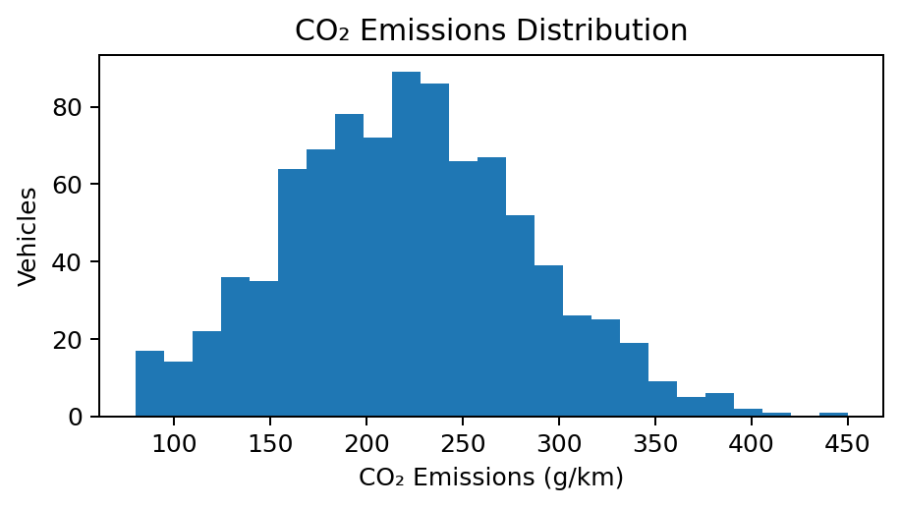  (a) Distribution of CO₂ emissions. | 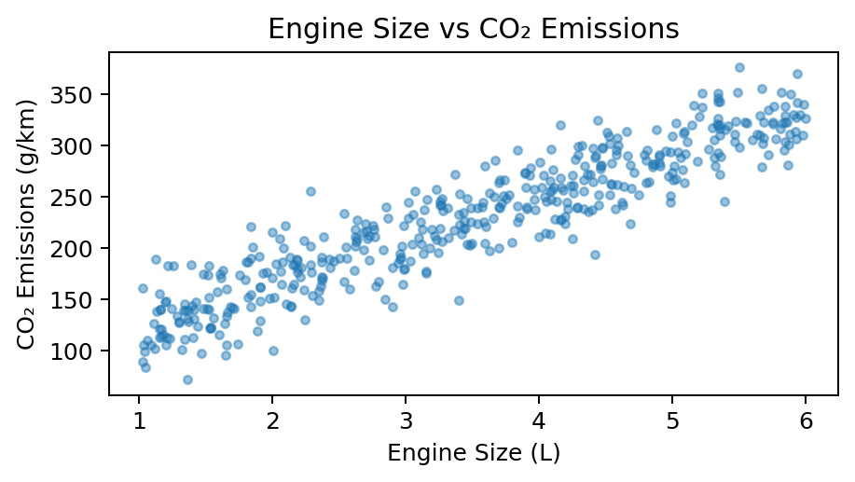  (b) Engine size vs CO₂ emissions.
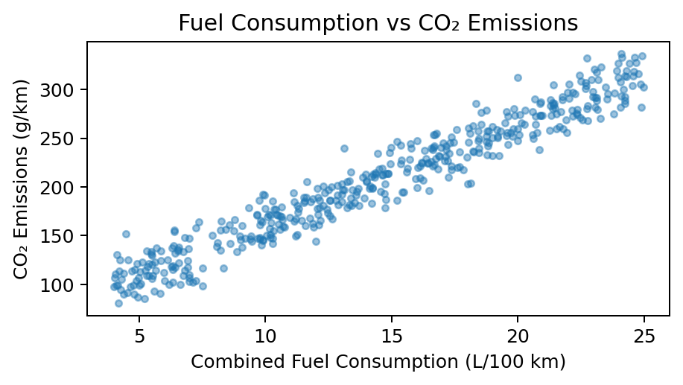  (c) Fuel consumption vs CO₂ emissions. | 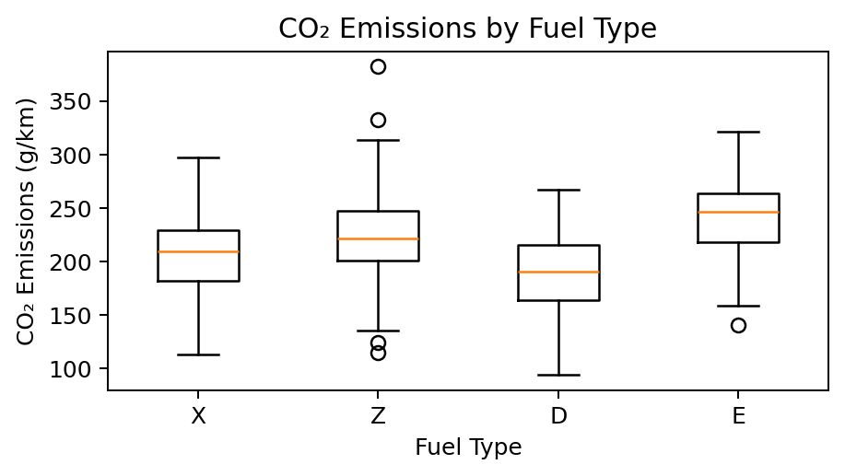  (d) CO₂ emissions by fuel type.
Fig. 2. Exploratory data analysis plots from the project notebook.
Several patterns are visible. (a) CO₂ emissions follow a roughly bell-shaped distribution between about 80 and 450 g/km, with most vehicles around 200–250 g/km and a thin right tail of high-emitting vehicles; because the target is continuous, its range, spread and skewness are reviewed instead of class counts. (b) Emissions rise steadily with engine size in a nearly linear pattern, with wider scatter for small engines. (c) Combined fuel consumption shows an even tighter, almost linear relationship with emissions, making it the strongest single indicator. (d) Median emissions differ between fuel types: ethanol (E) vehicles have the highest median (about 245 g/km) and diesel (D) the lowest (about 190 g/km), while regular (X) and premium (Z) gasoline lie in between; premium gasoline also shows a few high outliers.
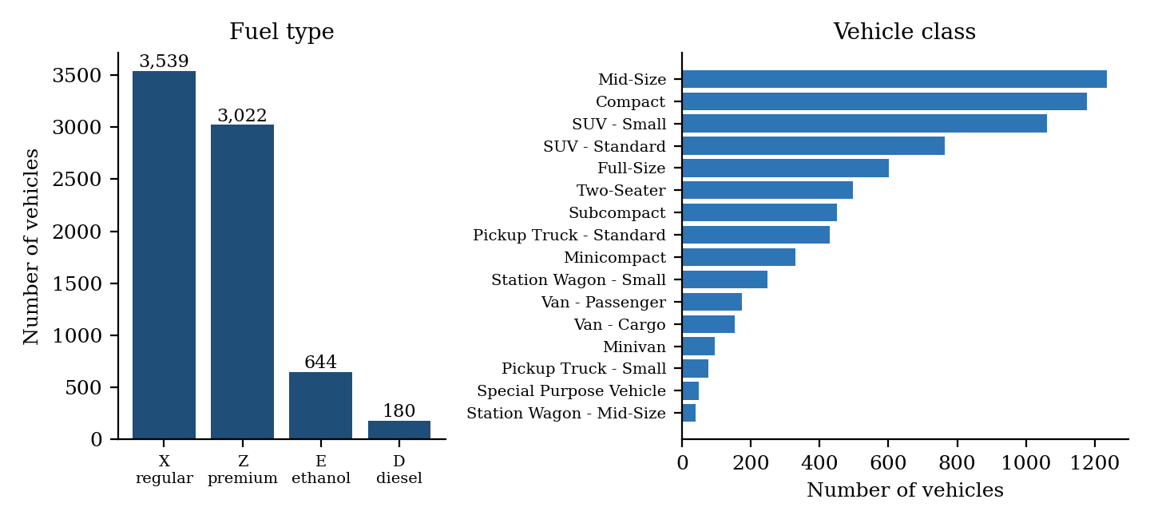
Fig. 3. Composition of the dataset by fuel type and vehicle class.
Fig. 3 shows the composition of the supplied dataset. Regular and premium gasoline together account for about 89% of the records, and mid-size, compact and small SUV vehicles are the three largest classes, so the model is trained mainly on mainstream gasoline passenger vehicles.
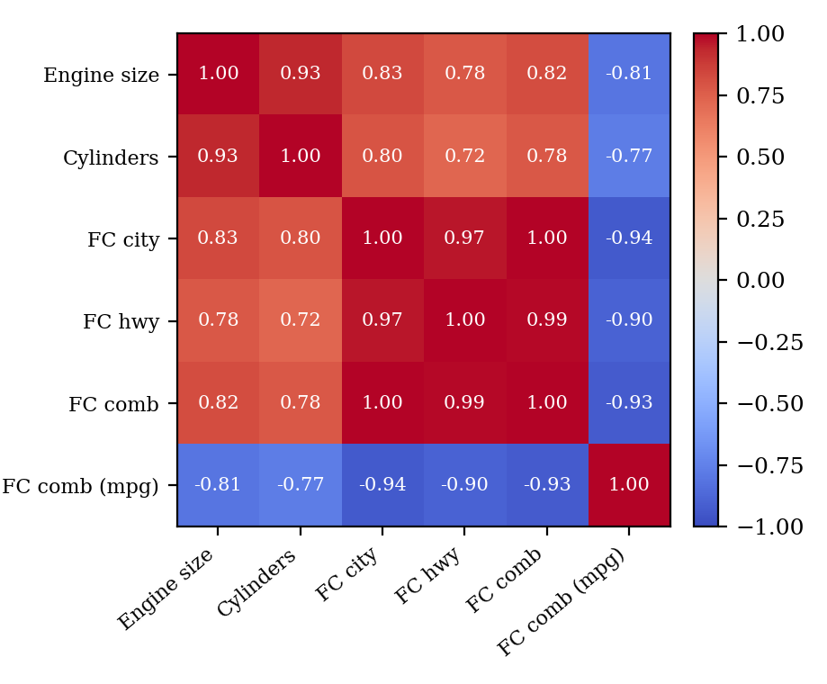
Fig. 4. Pearson correlation between the numeric attributes of the dataset (target excluded).
Fig. 4 shows the correlations among the numeric predictors. Engine size and number of cylinders are strongly related (r = 0.93), and the city, highway and combined fuel-consumption measures are almost interchangeable (r between 0.97 and 1.00). Combined fuel economy in mpg is inversely related to all of them (r from −0.77 to −0.94) because it expresses the same quantity per unit of fuel instead of per distance. This heavy overlap among predictors would make ordinary least squares unstable and is the main reason for choosing a regularised model.

3.6 Feature Engineering and Feature Selection (if applicable)
No new features were derived. Feature preparation consists of three decisions. First, Make (39 values) and Model (663 values) were dropped because they are identifiers rather than measurable properties; one-hot encoding them would add hundreds of sparse columns without giving useful physical information. Second, the categorical attributes Fuel Type, Vehicle Class and Transmission, with 4, 16 and 22 distinct values respectively in the supplied file, were one-hot encoded into 42 binary columns, which together with the numerical attributes form the design matrix. Third, the strongly correlated numerical attributes (Fig. 4) were not removed manually; instead, feature selection is handled inside the model, because the L1 part of the Elastic Net penalty can set the coefficients of weak features to zero and the L2 part keeps correlated features stable. The model-year attribute has the same value (2014) in every record of the supplied file, so it carries no predictive information.

3.7 Model Building and Training
The proposed model is Elastic Net Regression [11], a linear model whose coefficients are estimated by minimising the squared prediction error plus a combination of L1 (Lasso) and L2 (Ridge) penalties. In the parameterisation used by scikit-learn [12], the objective is: minimise (1 / 2n) ‖y − Xw‖² + α ρ ‖w‖₁ + (α (1 − ρ) / 2) ‖w‖₂², where w are the coefficients, α sets the overall penalty strength and ρ (l1_ratio) sets the balance between the L1 and L2 terms. The L1 term shrinks weak coefficients to exactly zero, performing feature selection, while the L2 term spreads weight across correlated features and reduces overfitting.
The model was implemented with scikit-learn’s ElasticNet class, which fits the coefficients by coordinate descent, and was trained on the 5,908 training records using the encoded and standardised features. Model quality was then checked on the 1,477 records that were held out. A separate baseline model was not trained in this project; instead, Section 4 compares the result with models reported in the literature.

3.8 Hyperparameter Tuning(if applicable)
Elastic Net has two hyperparameters, α (penalty strength) and l1_ratio (L1/L2 mix). The workflow described in this report fits a single Elastic Net configuration on the training split and evaluates it on the test split; it does not include a separate grid or random search. A cross-validated search over α and l1_ratio (for example with scikit-learn’s ElasticNetCV or GridSearchCV) is a natural extension and is listed under future work.

3.9 Model Evaluation
Because CO₂ emission is a continuous target, regression metrics are used. With y_{i} the actual emission, ŷ_{i} the predicted emission, ȳ the mean actual emission and n the number of test records:
- Mean Absolute Error (MAE) = (1 / n) Σ |y_{i} − ŷ_{i}| — the average size of the prediction error in g/km.
- Root Mean Squared Error (RMSE) = √[(1 / n) Σ (y_{i} − ŷ_{i})²] — also in g/km; it penalises large errors more heavily than MAE.
- R² score = 1 − Σ (y_{i} − ŷ_{i})² / Σ (y_{i} − ȳ)² — the share of the variation in emissions explained by the model; values near 1 indicate a close fit.

4. Results and Discussion

4.1 Preprocessing Results
Table 3 summarises the outcome of the preprocessing steps. The dataset contained no missing values, the identifier columns were removed, the three categorical variables were converted to binary indicator columns, and the numerical features were standardised before the data were divided into training and test sets.
Table 3. Preprocessing results.
Item | Result
Dataset size | 7,385 records × 12 columns, as loaded in the notebook
Missing values | None found in the supplied dataset, so no imputation was needed
Columns dropped | 2 (Make, Model)
Categorical encoding | Fuel Type, Vehicle Class and Transmission one-hot encoded (4 + 16 + 22 = 42 binary columns)
Scaling | StandardScaler applied to the numerical features
Training set | 5,908 records (80%)
Test set | 1,477 records (20%)

4.2 Model Performance
The Elastic Net model was trained on 5,908 records and evaluated on 1,477 unseen records. Rows marked “Existing study” are values reported in [1] (RMSE and R² only) on a similar vehicle CO₂ dataset and are shown for context; they are not directly comparable because the preprocessing and train–test split differ.
Table 4. Model performance on the test set (MAE and RMSE in g/km).
Model | Source | MAE | RMSE | R² score
Ridge regression | Existing study [1] | — | 4.93 | 0.9928
Lasso regression | Existing study [1] | — | 7.49 | 0.9834
Random Forest | Existing study [1] | — | 3.37 | 0.9966
XGBoost | Existing study [1] | — | 2.66 | 0.9979
Elastic Net Regression | Proposed (this work) | 4.76 | 7.08 | 0.9854

4.3 Visual Results and discussion
Fig. 5 places the RMSE and R² of the Elastic Net model beside those reported for four other regression models in [1]. The comparison is indicative only, since [1] used its own preprocessing (min-max scaling, feature selection and grouped categorical encodings) and its own train–test split.
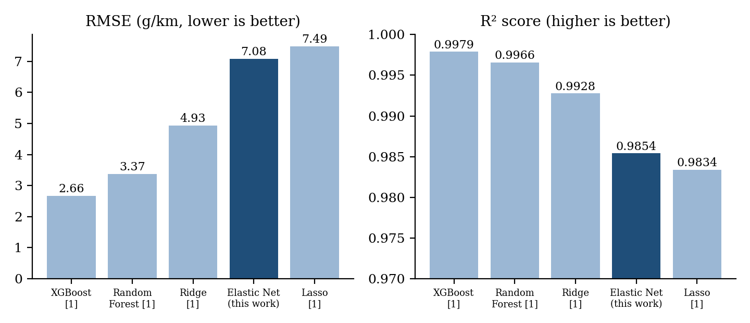
Fig. 5. RMSE and R² of the proposed Elastic Net model compared with models reported in [1].
Performance. The Elastic Net model reached an R² of 0.9854, meaning that about 98.5% of the variation in CO₂ emissions on the test set is explained by the vehicle features. The MAE of 4.76 g/km means that a typical prediction differs from the recorded value by less than 5 g/km. The RMSE of 7.08 g/km is about 1.5 times the MAE; because RMSE penalises large errors more heavily, this indicates that most predictions are very close while a minority of vehicles are predicted noticeably less accurately.
Why the model works well. The exploratory plots (Fig. 2(b) and 2(c)) show near-linear relationships between emissions and both engine size and fuel consumption, which suits a linear model. The L2 part of the penalty keeps the coefficients of the strongly correlated predictors (Fig. 4) stable, while the L1 part can remove weak indicator columns produced by one-hot encoding. That a regularised linear model performs competitively agrees with [2], which reported that linear models can match non-linear models on light-duty vehicle data while being easier to interpret.
Comparison with published results. In [1], Elastic Net’s result lies close to Lasso (R² 0.9834, RMSE 7.49) but behind Ridge (R² 0.9928, RMSE 4.93) and well behind the tree ensembles, Random Forest (R² 0.9966, RMSE 3.37) and XGBoost (R² 0.9979, RMSE 2.66). Plausible reasons are that a linear model cannot capture non-linear interactions among engine, fuel and transmission that tree ensembles can, that the penalty may shrink coefficients too much when α is not tuned, and that preprocessing and data splits differ between the studies. These are hypotheses to be tested rather than conclusions of this experiment.
Trade-offs, errors and generalisation. Elastic Net is simple, fast to train and interpretable, at the cost of some accuracy compared with boosted tree models. The reported metrics come from a single 80/20 split; training-set scores and cross-validation results were not recorded, so the degree of overfitting cannot be quantified, and predicted-versus-actual and residual plots, which would show where the errors concentrate, are not part of the current results. The dataset also covers a single market and fleet, a limitation noted for similar data in [3], so the model should not be assumed to hold for very different vehicle types such as hybrid or electric cars.

5. Conclusion
This project addressed the problem of estimating a vehicle’s CO₂ emissions (g/km) from its technical specification without physical testing. A vehicle dataset of 7,385 records was inspected, cleaned, encoded and standardised, explored visually, and used to train an Elastic Net Regression model on 80% of the data. On the 1,477 unseen test records, the model achieved an MAE of 4.76 g/km, an RMSE of 7.08 g/km and an R² of 0.9854, showing that engine size, cylinders, fuel type, transmission and fuel consumption explain almost all of the variation in emissions.
Elastic Net is a practical choice for this task because it is fast, interpretable and stable in the presence of strongly correlated predictors. Its accuracy is in line with other linear models reported in the literature but below that of boosted tree ensembles, so it is best seen as a strong and transparent baseline. Manufacturers, regulators and buyers can use such a model to obtain quick CO₂ estimates for a vehicle whose specification is known.

6. Future Work
- Use larger and more diverse datasets covering more model years and markets, including hybrid and electric vehicles.
- Compare Elastic Net with Ridge, Lasso, Random Forest and gradient-boosting models (XGBoost, LightGBM, CatBoost) on the same data split.
- Tune α and l1_ratio systematically with cross-validation, and report k-fold results instead of a single split.
- Analyse the learned coefficients and apply explainable-AI techniques such as SHAP, and add predicted-versus-actual and residual plots.
- Fit the scaler inside the training folds only (for example with a scikit-learn Pipeline) to rule out data leakage, and evaluate robustness as new vehicle models appear.
- Develop a simple web application in which a user enters engine, fuel and transmission details and receives the predicted CO₂ emissions.
- Validate the approach on external datasets, such as other countries’ vehicle fuel-consumption records.

7. References
References are listed in IEEE style and numbered in order of first citation in the literature survey; entries [11]–[13] support the methodology and dataset.
[1] F. Gurcan, “Forecasting CO₂ emissions of fuel vehicles for an ecological world using ensemble learning, machine learning, and deep learning models,” PeerJ Computer Science, vol. 10, art. e2234, 2024, doi: 10.7717/peerj-cs.2234.
[2] H. T. T. Vu and J. Ko, “Effective modeling of CO₂ emissions for light-duty vehicles: Linear and non-linear models with feature selection,” Energies, vol. 17, no. 7, art. 1655, 2024, doi: 10.3390/en17071655.
[3] M. S. Mungan and O. Arpa, “Estimation of CO₂ emissions from vehicles using machine learning and multi-model investigation,” Bulletin of the Polish Academy of Sciences: Technical Sciences, vol. 73, no. 4, art. e154287, 2025, doi: 10.24425/bpasts.2025.154287.
[4] R. Dhyan, H. K. Joy, R. Sridevi, J. A. Electa Alice, and D. Vanusha, “Machine learning and deep learning analysis of vehicle carbon footprint,” International Journal of Environmental Impacts, vol. 7, no. 2, 2024, doi: 10.18280/ijei.070213.
[5] A. B. S. Mahi, F. S. Eshita, M. T. Maisha, A. K. Saha, and S. M. R. Al Masud, “Green driving: Harnessing machine learning to predict vehicle carbon footprints and interpreting results with explainable AI,” in Machine Learning Technologies on Energy Economics and Finance, M. Z. Abedin and W. Yong, Eds. Springer, 2025, pp. 1–26, doi: 10.1007/978-3-031-95099-5_1.
[6] L. A. Joshy, R. K. Sambandam, D. Vetriveeran, and J. Jenefa, “Regression analysis using machine learning algorithms to predict CO₂ emissions,” in Proc. 18th INDIACom, 2024 11th Int. Conf. Computing for Sustainable Global Development, 2024, pp. 444–448, doi: 10.23919/INDIACom61295.2024.10499094.
[7] Y. Natarajan, G. Wadhwa, K. R. Sri Preethaa, and A. Paul, “Forecasting carbon dioxide emissions of light-duty vehicles with different machine learning algorithms,” Electronics, vol. 12, no. 10, art. 2288, 2023, doi: 10.3390/electronics12102288.
[8] A. H. Al-Nefaie and T. H. H. Aldhyani, “Predicting CO₂ emissions from traffic vehicles for sustainable and smart environment using a deep learning model,” Sustainability, vol. 15, no. 9, art. 7615, 2023, doi: 10.3390/su15097615.
[9] D. Tena-Gago, G. Golcarenarenji, I. Martinez-Alpiste, Q. Wang, and J. M. Alcaraz-Calero, “Machine-learning-based carbon dioxide concentration prediction for hybrid vehicles,” Sensors, vol. 23, no. 3, art. 1350, 2023, doi: 10.3390/s23031350.
[10] T. Parlar, “Predicting CO₂ emissions using machine learning methods: A comparative regression and feature importance analysis,” Balkan and Near Eastern Journal of Social Sciences, no. 11, pp. 168–171, 2025.
[11] H. Zou and T. Hastie, “Regularization and variable selection via the elastic net,” Journal of the Royal Statistical Society: Series B, vol. 67, no. 2, pp. 301–320, 2005, doi: 10.1111/j.1467-9868.2005.00503.x.
[12] F. Pedregosa et al., “Scikit-learn: Machine learning in Python,” Journal of Machine Learning Research, vol. 12, pp. 2825–2830, 2011.
[13] Government of Canada, “Fuel consumption ratings,” Open Government Portal. [Online]. Available: https://open.canada.ca/data/en/dataset/98f1a129-f628-4ce4-b24d-6f16bf24dd64

Signature of the Guide Course Instructor

